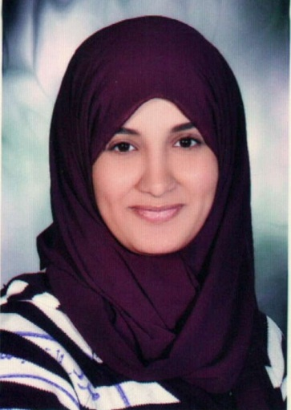**Biography**

**Sarah Ibrahim Hamed**

**Personal Information:**

**Name**: Sarah Ibrahim Hamed Khalaf Allah  
**Position**: Lecturer of Archaeology Faculty of Arts, Asyut University.  
**Date of Birth**: 02/05/1991   
**place of birth**: Asyut  
**Religion**: Muslim  
**Marital status**: Miss  
**Address**: July 26 Street New Awqaf Building Entrance B Flat 10  
**Major**: Islamic monuments  
**Specialization**: Islamic Arts  
**Phone home**: 0882352587  
**Mobile phone**: 01100071331  
**Work Phone**: 0882323000 (internal 5254)  
**Business Fax:** 0882328515  
**E-mail**: [sara.islamicart@yahoo.com](mailto:sara.islamicart@yahoo.com)

**Qualifications**:

• Bachelor of Arts - Department of Archaeology Faculty of Arts - Asyut University grade "very good" in 2011.  
• Pre-master of the Department of Archaeology Faculty of Arts, Asyut University - in 2012.

**International conferences:**  
• Audience participation in the first Conference of the Islamic impacts in the Muslim East Faculty of Antiquities, Cairo University in the period from December 8 to 12, 2013 m.  
• Audience participation in the seventeenth conference of the General Union of Arab Archaeologists 1 to 3 November 2014 m, Sheikh Zayed, Cairo.

**Membership of scientific associations:**  
• Member of the Union of Arab Archaeologists   
• Member of the Egyptian Society for Historical Studies.  
**Practical and Student Activities**:  
• Subscribe to the scientific supervision of the annual scientific trips for students of effects "Division Islamic monuments" section at the Faculty of Arts - University of Asyut to different cities Egypt: Cairo - Alexandria - Rashid - fowa "

**Scientific lectures:**   
• The lecture at the Library of Alexandria within the activities of Essam Mohammed Shanti session "indexing Arab manuscript" in the period from May 12 to 16, 2013, under the title: "Binding and the Arts manuscript."خبب